Problem 4

1. Mobile — 600px or less
Set the width to 304px.
Changes:
- Card becomes vertical.
- Image appears on top and details below.
- Font size becomes smaller.
- Padding reduces to 15px.
- Buy button becomes full width.
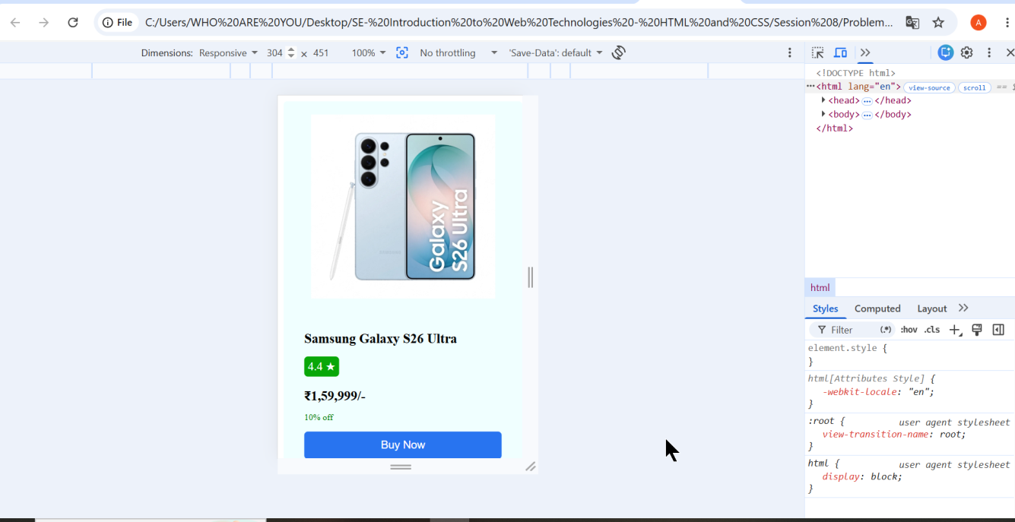

2. Tablet — around 768px
Set the width to 768px.
Changes:
- Card remains mostly horizontal.
- Card width becomes 90% .
- Padding reduces to 18px.
- Font sizes are slightly smaller than desktop.
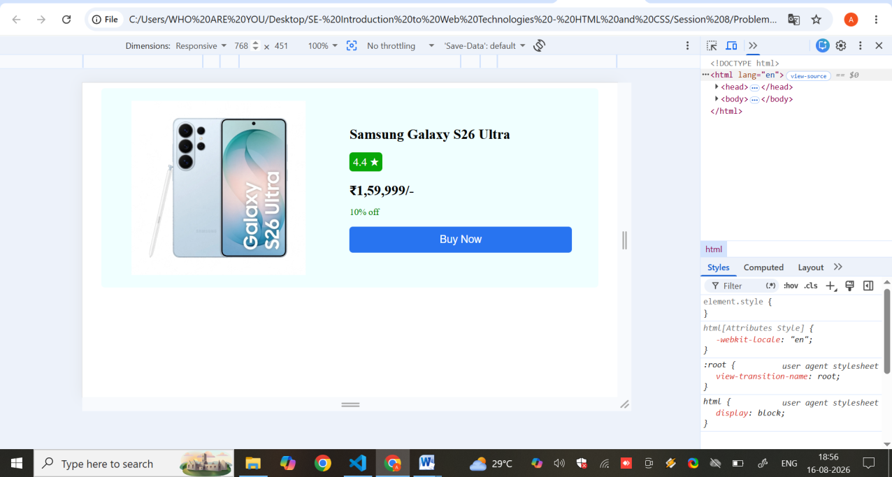

3. Desktop — 1200px or more
Set the width to 1200px or larger.
Changes:
- Image and product details appear side by side.
- Card uses larger padding.
- Fonts are larger for better readability.
- Product card has more spacing.
